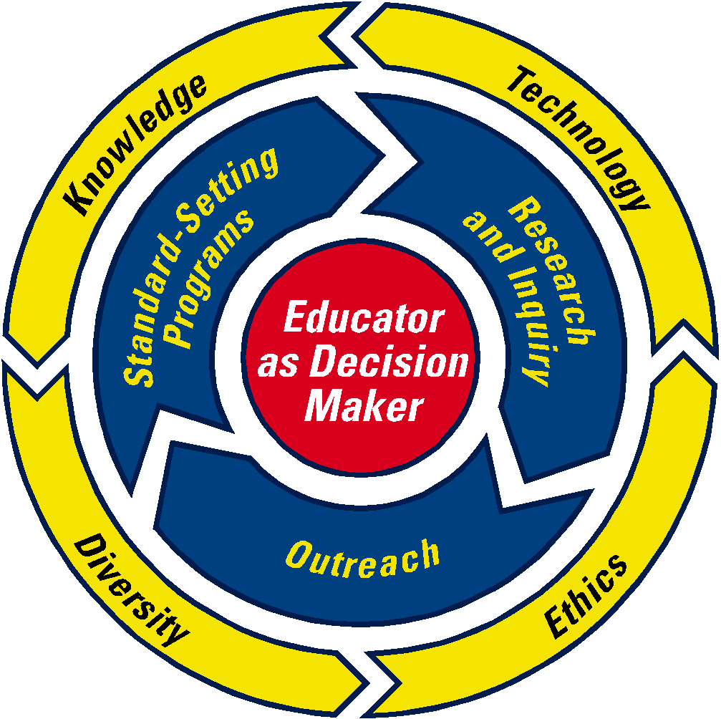
The University of Akron
College of Education
Department of Curricular and Instructional Studies

Educational Planning:
Instruction, Assessment, & Classroom Management
5500:360 (3 Semester Hours)

Instructor: usan Colvill\\\\e-Hall | Susan Colville-Hall |  | Section: 080
Office: Crouse |  |  | Building:Zook
Phone: 6258 |  |  | Room:401A
Email: colvill |  |  | Day/Time: | Monday 5:20-7:50
Office Hours:

I. COURSE DESCRIPTION

Prerequisites: 5500:230, 5100:200, 5100: 220, 5610:225. Theoretical foundations for standards-based thematic units and lesson plans, classroom assessment and organization; including procedures and models for mediating student behaviors and classroom management

II. RATIONALE

It is essential that preservice teachers understand the importance of integrating standards-based education, unit development, lesson plan development, assessment, classroom management, and behavioral supports for all students including those with diverse educational needs. This course provides the teacher candidate with the foundations necessary to begin development of the day-to-day skills such as classroom management that are critical in today’s pluralistic educational settings.

III. TEXTS – Required for both Educational Planning (5500 360) & Educational Implementation (5500 370)

Charles, C.M. (2011). Building classroom discipline (10th Ed.) Boston, MA: Allyn & Bacon.

Moore, K. D. (2012). Effective instructional strategies: From theory to practice (3rd edition). Thousand Oaks, CA: Sage Publications.

Ohio Academic Standards document for candidate’s licensure area – print and/or electronic version

IV. COURSE GOALS/OBJECTIVES

- Candidates understand learning theory, subject matter, curriculum development, and student development and know how to use this knowledge in planning instruction to meet curriculum goals. (Knowledge; OSTP 1.1, 4.4)

- Candidates understand principles and techniques, along with advantages and limitations, associated with various instructional strategies. (Knowledge; OSTP 2.2, 4.2)

- Candidates understand the principles of effective classroom management. (Knowledge; OSTP 5.1-5.5, 7.1)

- Candidates understand how students’ learning is influenced by individual experiences, talents, and prior learning, as well as language, culture, family, and community values and experiences. (Knowledge, Diversity; OSTP 1.2-1.5, 2.5)

- Candidates understand the characteristics, uses, advantages, and limitations of different types of assessments for evaluating how students learn, what they know and are able to do, and what kinds of experiences will support their further growth and development. (Knowledge; OSTP 3.1-3.5)

- Candidates understand measurement theory and assessment-related issues, such as validity, reliability, bias, and scoring concerns. Candidates demonstrate understanding of the Ohio’s state assessment plan, including the value-added component. (Knowledge; OSTP 3.1-3.5)

- Candidates select and create learning experiences that are appropriate for curriculum goals, relevant to learners, and based on effective instruction. (Knowledge; OSTP 2.1-2.5, 4.1-4.7)

- Candidates create lessons and activities that operate at multiple levels to meet developmental and individual needs of diverse learners. (Diversity; OSTP 1.1-1.5)

- Candidates describe a learning environment that encourages active, engaged learning; positive interaction; and self-motivation for all students. (Knowledge; OSTP 5.1-5.5)

- Candidates solicit and use information about students’ home and community, experiences, learning behavior, needs, and progress from parents, significant community resources, other colleagues, and the students themselves. (Knowledge, Ethics; OSTP 6.3, 6.4)

- Candidates value both long and short-term planning. (Knowledge; OSTP 2.3, 4.1, 4.3)

- Candidates value planning as a collegial activity among school and out-of school professionals and parents. (Knowledge; OSTP 6.3)

- Candidates will become familiar with the ethical guidelines for assessment and behavioral support. (Knowledge, Ethics; OSTP 7.1)

 | Objectives | UA Conceptual Framework Proficiencies | Ohio Standards for the Teaching Profession | Assignments/Assessments  [Portfolio items with asterisks (*)]
1 | Candidates demonstrate knowledge of learning theory, subject matter, curriculum development, and student development and know how to use this knowledge in planning instruction to meet curriculum goals. | Knowledge 1-4  Diversity 1 | 1.1  4.4 | Unit plan*  Lesson plan*
2 | Candidates demonstrate understanding of principles and techniques, along with advantages and limitations, associated with various instructional strategies. | Knowledge 1, 3  Technology 1 | 2.2  4.2 | Unit plan*  Lesson plan*
3 | Candidates demonstrate understanding of the principles of effective classroom management. | Knowledge 1 | 5.1-5.5  7.1 | Management plan *
4 | Candidates demonstrate understanding of how social groups function and influence people, and how people influence groups. | Knowledge 2  Diversity 1  Ethics 3 | 1.2-1.5  2.5 | Management plan *  Unit plan *
5 | Candidates demonstrate understanding of how students’ learning is influenced by individual experiences, talents, and prior learning, as well as language, culture, family, and community values and experiences. | Knowledge 1-3  Diversity 1  Ethics 1, 3 | 3.1-3.5 | Unit plan *  Lesson plan *
6 | Candidates demonstrate understanding of the characteristics, uses, advantages, and limitations of different types of assessments for evaluating how students learn, what they know and are able to do, and what kinds of experiences will support their further growth and development. | Knowledge 3, 4  Technology 2  Diversity 2  Ethics 3 | 3.1-3.5 | Unit plan *  Lesson plan *  Management plan *
7 | Candidates demonstrate understanding of measurement theory and assessment-related issues, such as validity, reliability, bias, and scoring concerns. | Knowledge 4  Diversity 2 | 2.1-2.5  4.1-4.7 | Unit plan *
8 | Candidates select and create learning experiences that are appropriate for curriculum goals, relevant to learners, and based on effective instruction.  Candidates create lessons and activities that operate at multiple levels to meet developmental and individual needs of diverse learners. | Knowledge 1-4  Technology 1-2  Diversity 1-2  Ethics 1, 3 | 1.1-1.5 | Unit plan *  Management plan *
9 | Candidates gather and use information about students’ home and community, experiences, learning behavior, needs, and progress from parents, significant community resources, other colleagues, and the students themselves. | Knowledge 2, 4  Diversity 1  Ethics 1 | 5.1-5.5 | Unit plan *  Lesson plan *  ODE website assignment  Profile
10 | Candidates demonstrate the value of both long and short-term planning. | Knowledge 1-4 | 6.3  6.4 | Unit plan *  Lesson plan *  Management plan *
11 | Candidates demonstrate the value of planning as a collegial activity among school and out-of school professionals and parents. | Ethics 1 | 2.3  4.1  4.3 | Unit plan *  Lesson plan *  Management plan *
12 | Candidates demonstrate commitment to the use of democratic values in the classroom. | Diversity 2  Ethics 1-3 | 6.3 | Unit plan *  Lesson plan *  Management plan *
13 | Candidates will demonstrate familiarity with the ethical guidelines for assessment and behavioral support. | Ethics 1, 3 | 7.1 | Management plan *  Philosophy of assessment

V. COURSE OUTLINE

Week | Topics | Related Readings and Resources
Weeks  1 – 2  Aug 27 | Qualities of effective teaching – planning, positive classroom environment, proven instructional techniques, professional behavior. Characteristics of schools and communities inform planning for instruction. Subject area content standards, benchmarks, and grade level indicators (or the equivalent). Role of content standards in curriculum planning. Backward design model for curriculum design. Subject-centered and student-centered curriculum patterns | Moore Chap 1, 6  Student Profile from Ed Psy course  ODE website
Week 3  Sep 10 | Setting goals and objectives; three domains of learning; writing objectives at different levels (cognitive, affective, and psychomotor). | Moore Chap 6
Week  4  Sep 17 | Development of the unit: Topics, sequence, standards, goals, learning activities, individualization and adaptations (academic and behavioral) incorporating children with disabilities and IEP’s. | Moore Chap 7
Weeks 5 - 6  Sep 24  Oct 1 | Evaluating and measuring learning: purpose of evaluation; kinds of evaluation; purposes, advantages, and limitations of kinds of evaluation; information sources. Ohio’s evaluation process, including, the value-added dimension | Moore Chap 8
Weeks  6 – 7  Oct 8  Oct 15 | Constructing tests: types of tests – advantages and disadvantages of each; test construction; assigning grades | Moore Chap 9
Weeks  8 – 9  Oct 22  Oct 29 | Teaching methods: overview of direct, integrated, and indirect methods; likenesses and differences; rationale for using; teacher-centered and student-centered methods; strengths and limitations (including ways to internationalize the curriculum) | Moore Chap 10, 11, 12, 13  ODE website  Value-Added PPT
Weeks  9 – 10  Nov 5  Nov 12 | Lesson planning: formats and structure; the Praxis lesson plan; approaches to internationalizing the curriculum | Moore Chap 10, 11, 12, 13; Social Studies and the Young Learner, Vol. 25, No. 2, Nov./Dec. 2012
Week  11  Nov 19 | Classroom management: Varying historical approaches to classroom management | Charles 1, 2 & 4
Weeks  12 – 13  Nov 26  Dec 3 | Classroom management: Varying current, theoretical approaches to classroom management | Charles 8, 11 & 13
Week  14  Dec 10 | Classroom management: Synthesis and application of theoretical approaches to classroom management to create a personal philosophy of classroom management; communication with parents and students regarding effective classroom management; classroom rules and positive/negative consequences | Charles 16
Week  15 | Communicating with students and parents: importance of positive dialogue; verbal, vocal, and metaverbal components; nonverbal communication; listening and feedback | Moore Chap 11
VI. INSTRUCTIONAL STRATEGIES/ACTIVITIES/TECHNOLOGY

  - Lecture
  - Media
  - Small group activities
  - Use of internet to access resources
  - Possible field trip to a site school, resource center or University curriculum library to view curriculum resources and materials
  - Review of curriculum resources specific to the local community (e.g. a nature center, zoo, museum, local library or community center)
  - Possible speakers on specialized topics such as behavioral support or formal assessment and the role of the classroom teacher
  - Enrichment readings and activities (e.g., studying the community of public schools as an activity…articles….multicultural community resources, culturally responsive teaching … assessment to instruction…value-added …etc.)

EVALUATION/STUDENT ASSESSMENT

- School District and Community Analysis

Candidates will conduct Internet searches of an assigned Ohio school district and surrounding community to identify district, school, classroom, and student characteristics to serve as the basis for the design of unit and lesson plans. School, district, and classroom sources include the assigned school district, the Ohio Department of Education, and other educational websites. Using narrative from your comprehensive project completed in 5100:220 (Educational Psychology) is permitted. Verification of completion of the5100:220 Comprehensive Project will satisfy assignment A.

Purpose: Teachers plan instruction with knowledge of the school and community of their students.

- Unit Plan (Portfolio Requirement)

Candidates will design a comprehensive unit plan for a selected class of students in a school located in the assigned school district for which characteristics were identified in assignment A. The unit must be related specifically to the Common Core Standards and new Academic Content Standards (or the equivalent) for the selected grade level(s). Day one should include a pre-assessment and set the stage for the unit; days two through seven should present new concepts and/or skills; days eight and nine should focus on an authentic assessment of students’ learning; and, on day ten the students should take a traditional test. The unit should reflect an understanding of the concepts related to curriculum, classroom management and instruction. The alignment of learned objectives, assessment, and instructional strategies must be demonstrated.

Purpose: Teachers’ work focuses on planning units of instruction aligned to requirements of curriculum standards and containing objectives, activities, and assessments appropriate for their learners.

- Lesson Plan (Portfolio Requirement)

Candidates will design one lesson plan selected from days 2-7 of the unit plan designed in assignment B. The plan must contain the Praxis format elements.

Purpose: Students’ learning is enhanced by their teachers’ thorough planning and delivery of lessons.

- Assessment

1) Candidates will explore features of the Ohio Department of Education website related to state-mandated assessments. Candidates will discuss Ohio’s Value-Added component to its assessment plan.
2) Candidates will demonstrate their comprehension of terms related to assessment and evaluation, including the appropriate use and interpretation of standardized tests as well as the legal and ethical issues involved in assessment including confidentiality.
3) Candidates will synthesize their understanding of assessment and evaluation to write their personal philosophy of assessment. In this report, the candidate will explain the purposes of assessment and evaluation; differentiate among different types of assessment; contrast the use of standardized tests with teacher-made tests; identify advantages and limitations of using different forms of assessment; and, identify how evaluations should be determined and reported. (See Assignment D Rubric)

Purpose: Assessments aligned to curriculum content and classroom instruction provide evidence of students’ learning.

E. Management Plan (Portfolio Requirement)

Candidates will design a comprehensive classroom management plan, which includes a portfolio quality paper on models/systems of discipline and the candidate’s professional philosophy of discipline and specifically outlines the discipline plan and other strategies for effective management of their future classrooms. Policies, procedures, and mechanisms for communication to students/parents should be included (Assignment E). NOTE: this task will be revisited and elaborated upon in the course, 5500:370, where it is also a Portfolio Requirement

Purpose: Planning classroom management requires an informed and articulated management philosophy to facilitate a teacher’s primary function – the achievement of learning for all students.

Course Grade: will be based on the following:

Assignment | Weighting | Points
- School Analysis  (Points earned X 1.25/15) | 5% | 15
- Unit Plan  (Points earned X 1.5/75) | 25% | 75
- Lesson Plan  (Points earned X 1.07/45) | 15% | 45
- Assessment Plan  (Points earned X 3.0/45) | 15% | 45
- Management Plan  (Points earned X 2.08/75) | 25% | 75
- Participation  (Grade out of 45 pts) | 15% | 45
TOTAL | 100% | 300

Assignment Grades will be based on the following:

93 -100% = A 80 - 82% = B- 67 - 69% = D+
90 - 92% = A- 77 - 79% = C+ 63 - 66% = D
87 - 89% = B+ 73 – 76% = C 60 - 62% = D-
83 - 86% = B 70 – 72% = C- Below 60% F

Required Use of Tk20

This following language is for all classes with key assessments in initial and advanced programs covered by the Tk20 Implementation Plan:

The professional education programs in the College of Education are accredited by the National Council for Accreditation of Teacher Education (NCATE). NCATE’s performance-based system of accreditation fosters competent classroom teachers and other educators who work to improve the education of all P-12 students. This accreditation means that students and the public can expect that the College lives up to its promises. It means students can have confidence that a degree or credential from a nationally recognized program has value.
The accreditation process requires us to develop a comprehensive assessment system, to record assessment data electronically, to analyze the data and to make changes based on what the data tell us. Such a system can only make our excellent programs even better. To help us in this effort, the College has purchased Tk20 Campus Tools for Higher Education, a comprehensive system for outcomes-based assessment, accountability and reporting. In addition to the fee paid by the College, students enrolled in the identified professional education programs are required to subscribe to Tk20. (Please see complete list of programs with the Tk20 requirement at http://www.uakron.edu/colleges/educ/tk20/programs.php .

Faculty in your program have selected certain key assignment artifacts that demonstrate you are developing the requisite knowledge, skills and dispositions for your field. Your requirements in this course include the electronic submission of specific key assignment artifacts using the Tk20 system.

Beginning in Fall 2010, the fee for currently enrolled students who have not previously purchased a Tk20 subscription is included on bills issued by the Bursar’s Office. If you have questions about your account, please email them to coetk20@uakron.edu .

VIII. CONCEPTUAL FRAMEWORK PROFICIENCIES
The following boilerplate language should appear on every syllabus of the
College of Education under the above heading:

The University of Akron, College of Education has identified Educator as Decision Maker as the theme of our conceptual framework, which has been developed around the core components of professional practice and scholarship identified in the mission statement of the college: Knowledge, Technology, Diversity, and Ethics. The theme and components provide direction for programs, courses, teaching, candidate performance, scholarship, service, and unit accountability. It is our goal to provide opportunities to candidates to develop a solid foundation in the identified proficiencies for each of the core components through well-planned coursework. This foundation then transfers into knowledge-based decision making as it applies to Standards Setting Programs, Research and Inquiry, and Outreach. Descriptions of the proficiencies are provided at http://www.uakron.edu/colleges/educ/COE/cf-proficiencies.php
As you progress through your program, you will find the conceptual framework aligned with course objectives. You will also find the conceptual framework theme and core components reflected throughout the College of Education. This reflects our commitment to these central tenets and our vision that all of our graduates will be effective decision makers throughout their professional careers.

IX. STUDENT ETHICS AND OTHER POLICY INFORMATION

For further information about The University of Akron's policies regarding student ethics and conduct, please consult the following sources: http://www.uakron.edu/gradsch/pdf/Gradbulletin.pdf, then select "General Information" (academic honesty); or http://www2.uakron.edu/studdev/ student_conduct.htm (Student Code of Conduct). Any student who feels she/he may need an accommodation based on the impact of a disability please consult www.uakron.edu/access and the Office of Accessibility at (330) 972-7928.

Absences: It is expected that students notify the instructor either by phone or email in advance or within 24 hours after the class meeting of any absence.

Cell phones: It is expected that cell phones not be used during class, except in extreme and unavoidable circumstances.

Lap Top Computers: The instructor reserves the right to ask students bringing lap top computers to class to shut off the computer if it is being used for work unrelated to the conduct of the class.

X. BIBLIOGRAPHY

Alderman, M. K. (2004). Motivation for achievement: Possibilities for teaching and learning, 2nd Ed. Mahwah, NJ: Lawrence Erlbaum and Associates

Alessi, S. M., & Trollip, S. R. (2001). Multimedia for learning: Methods and development (3rd ed.). Boston: Allyn and Bacon.

Cangelosi, J. S. (2000). Assessment strategies for monitoring student learning. New York: Longman.

Canter, L., & Canter, M. (2001). Assertive discipline: Positive behavior management for today's classroom (3rd ed.). Santa Monica, CA: Canter and Associates.

Carey, L. (2001). Measuring and evaluating school learning (3rd ed.). Boston: Allyn and Bacon.

Chase, C. I. (1999). Contemporary assessment for educators. New York: Longman.

Cooper, J. M., & Garrett, S. S. (1990). Classroom teaching skills (4th ed.). Lexington, MA: D. C. Heath.

Danforth, S., & Boyle, J. P. (2000). Cases in behavior management. Upper Saddle River, NJ: Merrill.

Dewey, J. (1933). How we think: A restatement of the relation of reflective thinking to the educative process. Boston, London: Heath.

El in, L. (2001). Designing and developing multimedia: A practical guide for the producer, director, and writer. Boston: Allyn and Bacon.

Farris, P. J. (2000). Key resources for future teachers. Boston: McGraw Hill.

Ford, B. A. (2002). African American community resources: Essential educational enhancers for African American Children and youth. In F. E. Obiakor & B. A. Ford (Eds.), Creating successful learning environments for African American exceptional learners (pp. 159-174). Thousand Oaks, CA: Corwin PressFort Worth: Harcourt Brace Jovanovich College Publishers.

Gunter, M. A., Estes, T. H., Schwab, J. H., & RHE Computer Education and Technology Zanesville. (1999). Instruction: A models approach (3rd ed.). Boston: Allyn and Bacon.

Heinich, R. (1999). Instructional media and technologies for learning. Upper Saddle River, NJ: Merrill.

Howell, J. H., & Dunnivant, S. W. (2000). Technology for teachers: Mastering new media and portfolio development. Boston: McGraw-Hill.

Hunter, M. C., & University of California Los Angeles. Office of Instructional Media. (1982). Mastery teaching. [Los Angeles, CA] Pacific Palisades, CA: UCLA Media Distributed by Instructional Dynamics.

Irvine, J. J., & Armento, B. J. (2001). Culturally responsive teaching: Lesson planning for elementary and middle grades. Boston: McGraw-Hill.

Jacobsen, D., Eggen, P. D., & Kauchak, D. P. (1999). Methods for teaching: Promoting student learning (5th ed.). Upper Saddle River, NJ: Merrill.

Johnson, D. W., & Johnson, R. T. (1999). Learning together and alone: Cooperative, competitive, and individualistic learning (5th ed.). Boston: Al lyn and Bacon.

Lockard, J., & Abrams, P. D. (2001). Computers for twenty-first century educators (5th ed.). New York: Longman.

Lyman, F. (1985). Think pair-share (Mimeograph). College Park, MD: University of Maryland.

Mager, R. F. (1984). Preparing instructional objectives (rev. 2nd ed.). Belmont, CA.: David S. Lake.

Marzano, R. J., Pickering, D., & McTighe, J. (1993). Assessing student outcomes: Performance assessment using the dimensions of learning model. Alexandria, VA: Association of Supervision and Curriculum Development.

McMillan, J. H. (2001). Classroom assessment: Principles and practice for effective instruction (2nd ed.). Boston: Allyn and Bacon.

Moore, K. D. (2001). Classroom teaching skills (5th ed.). Boston: McGraw-Hill.

Newby, T. J., & RHE Computer Education and Technology Zanesville. (2000). Instructional technology for teaching and learning designing instruction, integrating computers, and using media (2nd ed.). Upper Saddle River, NJ: Merrill.

Norton, P., & Sprague, D. (2001). Technology for teaching. Boston: Allyn and Bacon.

Ohio Department of Education. (1994). Social studies: Ohio's Model Competency-Based Program. Columbus, OH: Ohio Department of Education.
Ornstein, A. C., & Lasley, T. J. (2000). Strategies for effective teaching (3rd ed.). Boston: McGraw-Hill.

Powell, R. R. (2001). Classroom management: perspectives on the social curriculum. Upper Saddle River, NJ: Merrill/Prentice-Hall.

Raths, L., Harrnin, M., & Simon, S. (1996). Values and Teaching Columbus, OH: Charles Merrill.

Roblyer, M.D., & Edwards, J. (2000). Integrating educational technology into teaching. Upper Saddle River, NJ: Merrill.

Schmuck, R. A., & Schmuck, P. A. (2001). Group processes in the classroom (8th ed.). Boston: McGraw Hill.approach to instructional design. Boston: Allyn and Bacon.

Tanner, D. E. (2001). Assessing academic achievement. Boston: Allyn and Bacon.

Thompson, S. J. (2000). Decision-making in planning and teaching. New York: Longman.

Thompson, S.J., Kushner-Benson, S.N., Pachnoswksi, L.M., and Salzman, J.A. (2001). Decision-making in planning and teaching. New York: Peterson Publishing.

Tiene, D., & Ingram, A. (2001). Exploring current issues in educational technology. Dubuque, IA: McGraw-Hill.

Tishman, S., Perkins, D. N., & Jay, E. (1995). The thinking classroom: Learning and teaching in a culture of thinking Boston: Allyn and Bacon.

Trenholm, S. (1999). Thinking through communication: An introduction to the study of human communication (2nd ed.). Boston: Allyn and Bacon.

Wittrock, M. C. (1986). Handbook of research on teaching (3rd ed.). New York London: Macmillan Collier Macmillan.

BIBLIOGRAPHY DEALING WITH CLASSROOM MANAGEMENT

Alderman, M. K. (2004). Motivation for achievement: Possibilities for teaching and learning, 2nd Ed. Mahwah, NJ: Lawrence Erlbaum and Associates

Curwin, R. L. & Mendler, A. N. (1999). Discipline with dignity. Columbus, OH: Merrill Prentice Hall.

Edwards, C. (2000). Classroom discipline and management (3rd ed.). New York, John Wiley & Sons.

Emmer, E., Evertson, C., Worsham, M. (2000). Classroom management for secondary teachers (5th ed.). Boston: Allyn and Bacon.

Evertson, C., Emmer, E., & Worsham, M. (2000). Classroom management for elementary teachers (5th ed.). Boston: Allyn and Bacon.

Kohn, A. (1996). Beyond discipline: From compliance to community. Columbus, OH: Merrill Prentice-Hall.

McQueen, T. (1992). Essentials of classroom management and discipline. New York, Harper Collins Publishers.

McEwan, B. (2000). The art of classroom management: Effective practices for building learning communities. Upper Saddle River, NJ: Merrill.

